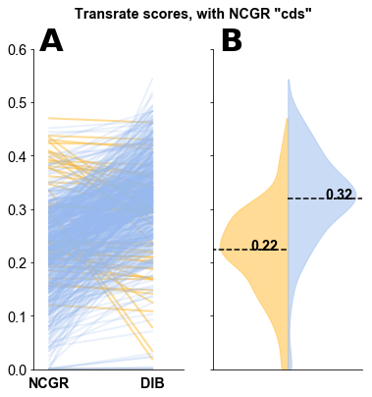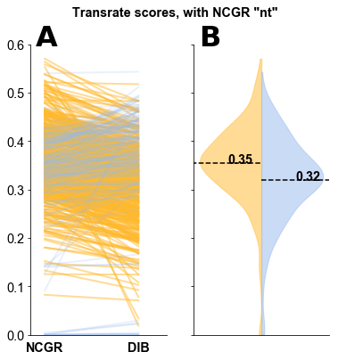

Supplemental Figure 1. Transrate score comparisons between DIB re-assemblies and the two versions of the NCGR assemblies: (A) nucleotide, ‘nt’ (B) and coding sequence, ‘cds’. The ‘nt’ version of the NCGR assembly contains all contigs assembled by the NCGR pipeline. The ‘cds’ version was filtered by NCGR to include only the coding sequences. Slope graphs (left side of each panel) compare the NCGR assemblies and DIB re-assemblies between the same samples. Violin plots (right side of each panel) show the distribution of Transrate scores in the NCGR assemblies (yellow) and the DIB re-assemblies (blue).